First – create the new connection to the NEW Active Directory Server in the License Server Admin Utility>Server Options>LDAP – Add Active Directory.

Then you MUST stop the Seapine License Server service BEFORE updating the user records in the database.  If you don’t cache gets all sorts of messed up and things go wrong.  I always STRONGLY suggest taking a FULL back up before making any changes to the database. This is the ONLY recovery method if something goes wrong.

First determine what the NEW Active Directory connection idRecord is in the lsldapserver table:

select \* from lsldapserver

Then you look at the ldapsrvid column in the LSUSERS table:

Select \* from LSUSERS

So my “old” connection is “3” and you can see I have some users that are associated with it.

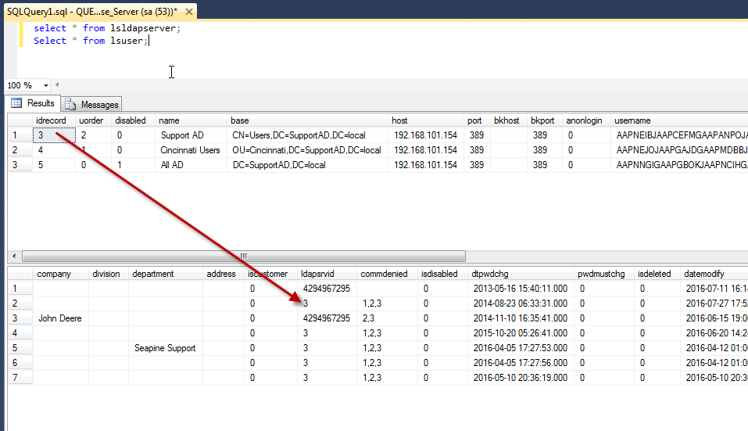

Now you are going to update the ldapsrvid column in the LSUSERS table with the idrecord of the NEW Active Directory connection you created in the License Server Admin Utility:

My statement to update to the “Cincinnati Users” connection would be:

Update lsuser

SET ldapsrvid=4

WHERE ldapsrvid=3;

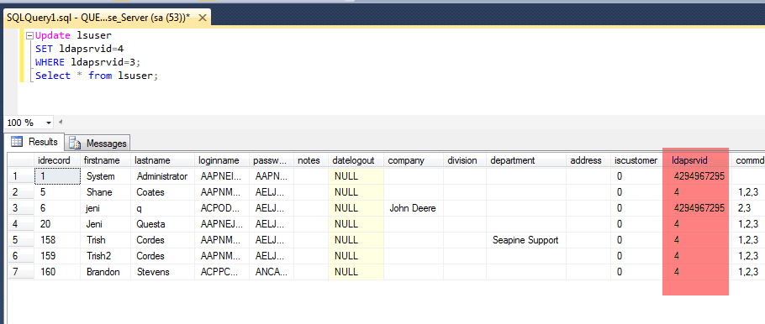

You will see a big long value “4294967295” -- this means the user record is NOT currently associated with an LDAP\AD connection.

Once the update is finished you can start the Seapine License Server service.